Reliable person detection in drone videos

Atul Gupta  IIT HYD  CS16EMDS11004@iith.ac.in | Chandra  IIT HYD  CS16EMDS11006@iith.ac.in | Vijin K P  IIT HYD  CS16EMDS11030@iith.ac.in

Abstract

State of the art object detection network in a drone video give good accuracy on a particular dataset but lack a good accuracy on other datasets. Also, the standard object detection networks detect multiple classes. In this work we share a network trained and tested after research of multiple networks. The network uses only two classes – person and background and it works for different type of drones at different angles and heights.

Introduction
Recent advances in object detection led to number of such networks. E.g. SSD, YOLO, R-CNN, Fast R-CNN, Faster R-CNN and RFCN. These networks are trained and tested on the standard datasets e.g. PASCAL VOC 2007, 2010 and MS COCOA. The state of the art performance of the networks on these datasets has been very good. These networks are in turn trained and tested on different drone videos datasets with minor modifications. Also, the performance as mAP and Recall was presented on one dataset. However, networks are not tested on variety of datasets and the performance of the networks is unknown on other datasets.

Objective
In this paper, we develop a single framework which is trained and tested using multiple drone datasets to give good results on each of those datasets. The network is trained with only two classes person and background and the measurement of the results is also based on those two networks.

Related Work

RCNN
Object detection performance, as measured on the canonical PASCAL VOC Challenge datasets, plateaued in the final years of the competition. The best-performing methods were complex ensemble systems that typically combined multiple low-level image features with high-level context
RCNN was a simple and scalable detection algorithm that improves mean average precision (mAP) by more than 50 percent relative to the previous best result on VOC 2012-achieving a mAP of 62.4 percent.
The approach combined two ideas: (1) applying high-capacity convolutional networks (CNNs) to bottom-up region proposals to localize and segment objects and (2) when labeled training data are scarce, supervised pre-training for an auxiliary task, followed by domain-specific fine-tuning, boosts performance significantly

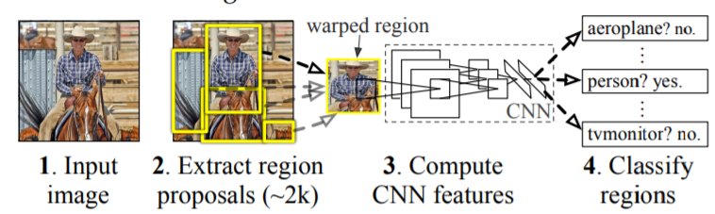

Fast R-CNN
Fast R-CNN builds on previous work to efficiently classify object proposals using deep convolutional networks. Compared to previous work, Fast R-CNN employed several innovations to improve training and testing speed while also increasing detection accuracy. Fast R-CNN trains the very deep VGG16 network 9x faster than R-CNN is 213x faster at test-time, and achieves a higher mAP on PASCAL VOC 2012. Compared to SPPnet, Fast R-CNN trains VGG16 3x faster, tests 10x faster, and is more accurate
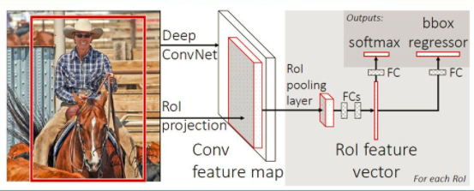

Faster R-CNN
Region Proposal Network (RPN) was introduced in Faster R-CNN that shares full-image convolutional features with the detection network, thus enabling nearly cost-free region proposals. An RPN is a fully convolutional network that simultaneously predicts object bounds and objectless scores at each position. The RPN was trained end-to-end to generate high-quality region proposals, which were used by Fast R-CNN for detection.
RPN and Fast R-CNN were merged into a single network by sharing their convolutional features---using the recently popular terminology of neural networks with 'attention' mechanisms, the RPN component tells the unified network where to look. For the very deep VGG-16 model, the detection system has a frame rate of 5fps (including all steps) on a GPU, while achieving state-of-the-art object detection accuracy on PASCAL VOC 2007, 2012, and MS COCO datasets with only 300 proposals per image.
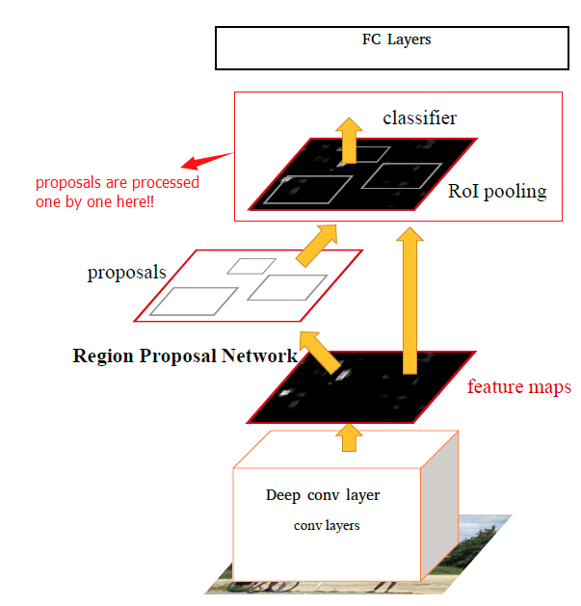

Mask RCNN
Mask RCNN efficiently detects objects in an image while simultaneously generating a high-quality segmentation mask for each instance
Mask R-CNN extends Faster R-CNN by adding a branch for predicting an object mask in parallel with the existing branch for bounding box recognition. Mask R-CNN is simple to train and adds only a small overhead to Faster R-CNN, running at 5 fps.
Mask R-CNN outperformed all existing, single-model entries on every task, including the COCO 2016 challenge winners.
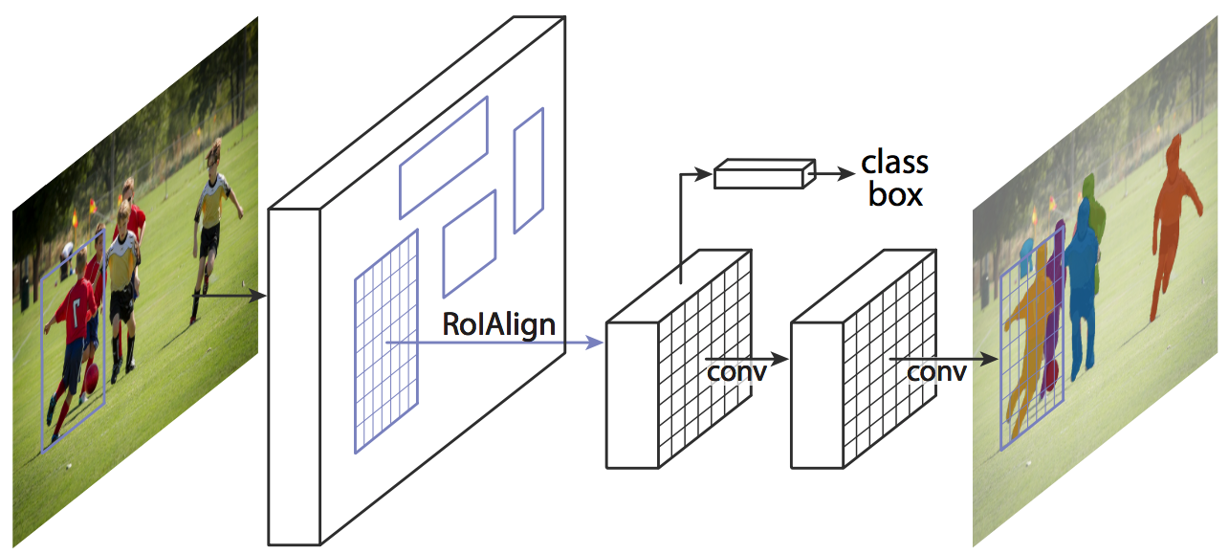

SSD
SSD, discretizes the output space of bounding boxes into a set of default boxes over different aspect ratios and scales per feature map location. At prediction time, the network generates scores for the presence of each object category in each default box and produces adjustments to the box to better match the object shape. Additionally, the network combines predictions from multiple feature maps with different resolutions to naturally handle objects of various sizes
SSD model is simple relative to methods that require object proposals because it completely eliminates proposal generation and subsequent pixel or feature resampling stage and encapsulates all computation in a single network. This makes SSD easy to train and straightforward to integrate into systems that require a detection component. Experimental results on the PASCAL VOC, MS COCO, and ILSVRC datasets confirm that SSD has comparable accuracy to methods that utilize an additional object proposal step and is much faster, while providing a unified framework for both training and inference. Compared to other single stage methods, SSD has much better accuracy, even with a smaller input image size. For 300×300 input, SSD achieves 72.1% mAP on VOC2007 test at 58 FPS on a Nvidia Titan X and for 500×500 input, SSD achieves 75.1% mAP, outperforming a comparable state of the art Faster R-CNN model

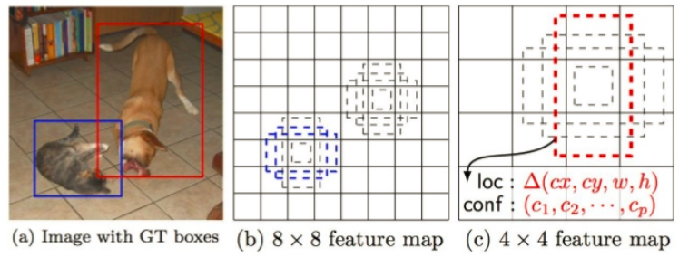

Approach
We begin by evaluating the existing state-of-the-art object detection frameworks on the drone data sets and then describe the novel network architecture that produces significantly improved results on the three different drone datasets.

Evaluation of object detection frameworks
Networks

The majority of object detection methods, including R-CNN, Fast R-CNN, Faster R-CNN, R-FCN, SSD, YOLO and Mask R-CNN, use the top-most layer of a ConvNet to learn to detect objects at different scale. We have chosen three methods, Faster R-CNN, R-FCN and SSD for the evaluation. R-CNN and Fast R-CNN is ignored as they are the predecessors of Faster R-CNN. Similarly, YOLO is very similar to SSD as both use single shot approach. Mask R-CNN is built on top of Faster R-CNN to provide pixel level segmentation in addition to detection.

All the three networks calculate a feature map using a ConvNet and then use different methods to decode detection results from the feature map. Faster R-CNN have proposed a method called Region Proposal Network (RPN) that generates predefined number of regions (bounding boxes), which may contain objects and these region proposals are used for detection. While R-FCN proposes the position sensitive score map to share more computation. SSD uses multi-scale feature maps by adding many feature maps decreased progressively in late layers of the base ConvNet and make object predictions based on these feature maps instead of using only a feature map in the last layers.

Performance metrics

In this paper, to evaluate efficiencies of models on the whole datasets used we use Average Precision, Average Recall, Average Precision and Average Recall across scales (small: area < 32², medium: 32² < area <96², high: area > 96²), and F-1 measure at 0.5 IoU (Intersection over Union).

Average Precision = ∑ (True Positive)/ ∑ (True Positive) + ∑ (False Positive)

Average Recall = ∑ (True Positive)/ ∑ (True Positive) + ∑ (False Negative)

F-1 measure = (2 * Precision * Recall) / (Precision + Recall)

Intersection over Union (IoU) = Area of Overlap / Area of Union

Datasets:

Mini-drone Video Dataset: This dataset consists of 38 different contents captured in full HD resolution, with a duration of 16 to 24 seconds each, shot with the mini-drone Phantom 2 Vision+ in a parking lot. The dataset contents can be clustered in three categories: normal, suspicious, and illicit behaviors. Normal content depicts people walking, getting in their cars and parking their vehicles. In suspicious content, nothing a priori wrong happens but people act in a questionable way. Contents with illicit behaviors show people wrong parking their vehicles, stealing items and cars, or fighting.

Okutama-Action Aerial View Video Dataset: This video dataset is meant for aerial view concurrent human action detection. It consists of 43 minute-long fully-annotated sequences with 12 action classes which are captured with drone. Okutama-Action features many challenges missing in current datasets, including dynamic transition of actions, significant changes in scale and aspect ratio, abrupt camera movement, as well as multi-labeled actors.

Stanford Drone Dataset: A large scale dataset that collects images and videos of various types of agents (not just pedestrians, but also bicyclists, skateboarders, cars, buses, and golf carts) that navigate in a real world outdoor environment such as a university campus. This dataset is meant for tasks such as target tracking or trajectory forecasting.

Even though all the three datasets are not primarily dedicated for person detection, we are using person annotations from drone videos for evaluating efficiencies of models. These datasets are carefully choosen as they are having varying object sizes. Mini-drone dataset is captured from a lesser altitude hence have larger objects whereas Stanford dataset is captured from a higher altitude hence smaller objects. Okutama dataset have medium size objects.

Evaluation:

As mentioned above, we used three models SDD, Faster R-CNN, R-FCN, to make our evaluation. Based on the performance metrics, we will use one of three models as the base model for further enhancements to accomodate small and large object detections.

Architecture
As we have not arrived on the final architecture to accommodate small and large object detections, this portion will be completed in final report.

Following are the high level experiments we are planning to carry out on next midterm.

- Fine-tuning / transfer learning on larger object trained model (Mini-drone dataset) with medium/smaller object data.

- Passing the semantic information captured in convolutional forward computation back to the shallower layers will improve the detection performance of small objects. (Feature-Fused SSD)

- Forking two different branches from CNN feature map to train small and large images and final detection (confidence, bounding box offset) by weighted sum of two branches. (Scale-aware Fast R-CNN for Pedestrian Detection)

Results

References
- Mini-drone video dataset: M. Bonetto, P. Korshunov, G. Ramponi, and T. Ebrahimi. Privacy in Mini-drone Based Video Surveillance. Workshop on De-identification for privacy protection in multimedia, Ljubljana, Slovenia, 2015.
- Okutama-Action: An Aerial View Video Dataset for Concurrent Human Action Detection M. Barekatain, M. Martí, H. Shih, S. Murray, K. Nakayama, Y. Matsuo, and H. Prendinger. The IEEE Conference on Computer Vision and Pattern Recognition (CVPR) Workshops, 2017.
- Stanford Drone Dataset: A. Robicquet, A. Sadeghian, A. Alahi, S. Savarese, Learning Social Etiquette: Human Trajectory Prediction in Crowded Scenes in European Conference on Computer Vision (ECCV), 2016.
- Feature-Fused SSD: Cao, G., Xie, X., Yang, W., Liao, Q., Shi, G., & Wu, J. (2017). Feature-Fused SSD: Fast Detection for Small Objects. CoRR, abs/1709.05054.
- Scale-aware Fast R-CNN for Pedestrian Detection: Xu, T., Liang, X., Shen, S., Feng, J., & Yan, S. (2018). Scale-Aware Fast R-CNN for Pedestrian Detection. IEEE Transactions on Multimedia, 20, 985-996.
- R-CNN: Girshick, R.B., Donahue, J., Darrell, T., & Malik, J. (2014). Rich Feature Hierarchies for Accurate Object Detection and Semantic Segmentation. 2014 IEEE Conference on Computer Vision and Pattern Recognition, 580-587.
- Fast R-CNN: Girshick, R.B. (2015). Fast R-CNN. 2015 IEEE International Conference on Computer Vision (ICCV), 1440-1448.
- Faster R-CNN: Ren, S., He, K., Girshick, R.B., & Sun, J. (2015). Faster R-CNN: Towards Real-Time Object Detection with Region Proposal Networks. IEEE Transactions on Pattern Analysis and Machine Intelligence, 39, 1137-1149.
- R-FCN: Dai, J., Li, Y., He, K., & Sun, J. (2016). R-FCN: Object Detection via Region-based Fully Convolutional Networks. NIPS.
- SSD: Liu, W., Anguelov, D., Erhan, D., Szegedy, C., Reed, S.E., Fu, C., & Berg, A.C. (2016). SSD: Single Shot MultiBox Detector. ECCV.
- YOLO: Redmon, J., Divvala, S.K., Girshick, R.B., & Farhadi, A. (2016). You Only Look Once: Unified, Real-Time Object Detection. 2016 IEEE Conference on Computer Vision and Pattern Recognition (CVPR), 779-788.
- Mask R-CNN: He, K., Gkioxari, G., Dollár, P., & Girshick, R.B. (2017). Mask R-CNN. 2017 IEEE International Conference on Computer Vision (ICCV), 2980-2988.

